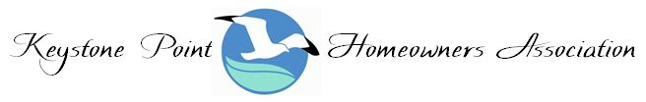
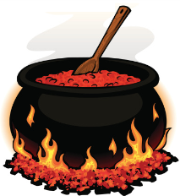
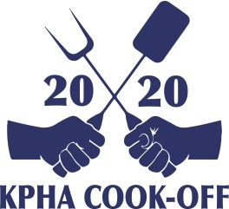
PARTICPATING COOK-OFF TEAMS
INFORMATION & GUIDELINES
Thank you for participating in KPHA 2020 SPRING COOK-OFF
Savory Chili to Sweet Desserts

We appreciate your participation, and we know that it’s going to be a fun-packed day for you, your families and neighbors. Entertainment and kids’ activities are planned throughout the day. And an awards presentation will showcase your talents for the Best Chili and the Best Desert. There are two categories in which to compete and cash awards to win!
Please read the information below so that when you arrive to set-up on Saturday, April 4th, 2020, beginning at 9:00 am, you’ll know what to expect.
Any questions or concerns please contact Justin Soucy (305) 333-3346 or justinsoucy0307@gmail.com.
Looking forward to seeing you at the KPHA Cook-Off, Keystone Field, Saturday, April 4th

- SCHEDULE OF EVENTS
9:00 am: Gates open for all contestants to begin set-up. Start your fires, set-up your space and start cooking!
Check-in at the team table located on the west gate. Pick up your credentials, people’s choice ballot box and blind box for judging.
12:00 pm: Gates open for general admission. Sampling begins.
1:45 pm: All entries must be submitted in numbered blind box that was distributed at the team check-in table.
2:00 pm: Blind judging begins
3:00 pm: Deliver People’s Choice Ballot Box to the Judges’ Tent for tallying.
3:30 pm: Awards ceremony on center stage
4:00 pm: Gates close. Clean-up begins to be completed by 6:30 pm
7:00pm: Park closes

- Parking Details & Load-in
Use the west side of field gates for entrance to the field.
Check-in registration table will be located at the same west side entrance gate.
Unload all equipment that you’ll need for your team’s set-up.
Vehicle parking is available along the alley on NE 18 Ave, behind Flannigan’s south lot.
North Miami Police will be there to provide security and to direct traffic.
Please remember that the alley spaces might be roped off for a fire engine and police car for kids
If you have any special needs, please let us know immediately. All KPHA volunteers will be wearing gray shirts.

- KPHA will Provide
For Sampling: Tasting plates, forks, spoons, knives, napkins
For Clean-up: Container for Hot Ash Disposal
Food for general admission guests: hot dogs, hamburgers, soft drinks, popcorn and chips
Electric hook-up if needed. Generators will be on site.
Awards for the Best Chili and the Best Dessert for each category
Cook-off T-Shirts to registered participating team members
Entertainment, games and kids’ activities throughout the day. Prizes to win!
Tool Kit and an Emergency Kit

- Teams to Provide
Teams must provide their own cooking equipment, fire extinguishers, extension cords, disposable gloves, hand sanitizer, tables, chairs, décor, pop-up tent, trash bags, paper towels, soap, coolers with ice, beverages and anything else that you might want to have at your station throughout the day.
Please remember that GLASS is not permitted on the event site/field.
All beverage containers must be paper, plastic or aluminum.
If you are bringing a grill, please provide charcoal and a fire extinguisher.
Propane for cooking is also allowed on site for cooking
Generators will be on-site for power hook-up. If you are using a crock pot or an electric hot plate, bring an extension cord/cords to plug into generators’ power strip.
Contact Justin Soucy (305) 333-3346 or justinsoucy0307@gmail.com for details.

- Clean-up
Teams can begin to clean-up after submitting their entry and their sampling is over.
Water hoses will be on site for clean-up only.
A hot coal receptacle will be available for you to dispose your hot ash during the event break-down.
No ash is to remain on the field. PLEASE keep the park site clean!
The community center restrooms will be open and available.
Trash receptacles will be provided by the city and collected throughout the event.
Contact Stuart Corenblum 305-588-5646 for ash pick-up

- PARTICPATING TEAM DETAILS
All participating teams will provide: For competition entry and sampling
― a minimum of 5 lbs of cooked Chili (finished product)
― a minimum of 50 dessert portions.
Chili Competition Entry: Each Judge to receive 2 oz (1/3 cup) portion. Remaining Chili to be sampled by consumers; 1-2 oz. portions.
Dessert Entry: Desserts are to be sampled and voted on by consumers. Each attendee will receive one ticket for one vote for the People’s Choice of Best Dessert.

- RULES & REGULATIONS: Chili Category
Entries can be cooked and/or prepared on or off site. Teams will be provided with containers for judging. Each team will present Five (5) servings in their boxes, one for each Judge.
Box with official team number will be provided by KPHA and will be distributed at check-in.
All entries will be blind judged by a team of Five (5) distinguished judges
All entries will be judged on appearance and taste. 1-10 point scale
1=Poor, 5= Average, 10= Excellent
The team with the most points in each category will become the KPHA 2020 Cook-Off Grand Champions
2nd place and 3rd place winners for Best Chili. Dessert winners will be by People’s Choice votes.
All judging decisions are FINAL – No Ties!
All entries MUST be submitted to the judging area no later than 1:45 pm in an authorized container.
- RULES & REGULATIONS : People’s Choice Award for BEST DESSERT
Make your favorite homemade dessert.
In order for your team to compete, you should be able to provide a minimum of 75 tasting portions, which will be judged by general admission guests using a ballot entry.
Ballot boxes will be handed out to each team upon entering the event gate.
Your Team # must appear on the ballot box to be valid.
Ballot boxes will be located at every participating People’s Choice Team’s table
All ballots must be cast by 3:30 pm to qualify.
Boxes are to be delivered to the Judges’ tent by a team member for tabulation by 3:30 pm
Team members competing in this category cannot vote for themselves.

